**Mean, Median**

Mean = sum/n ( sum / float(n) )

Median = m1 + m2 / 2

**Standard Deviation**

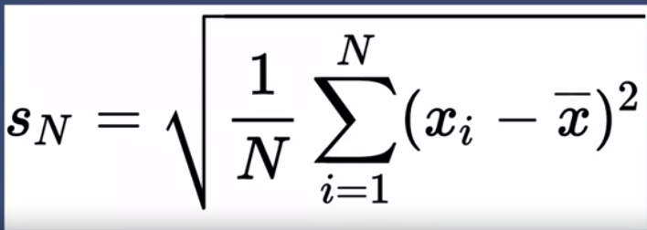

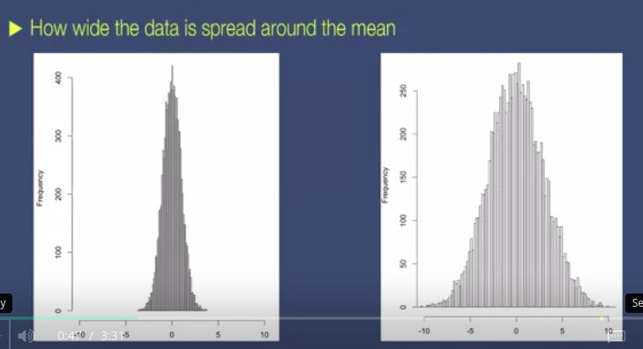

**Simple definition: SqRoot ( ( 1/n ) Sum(Each value - mean)^2 )**

In Spark: (mean & sd)

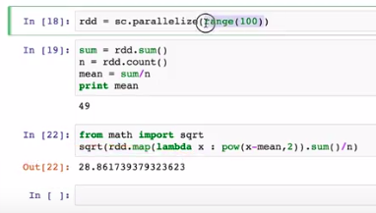

Mean is 49, but all values are spread around 28.86 ( lower/ left of the mean)

Outlier - last/ most significant value : If it s far away from the mean, sd will also change,

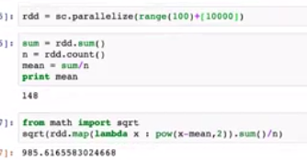

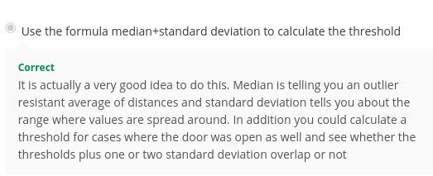

**Variance:**

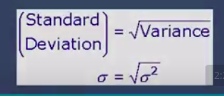

**Skewness**

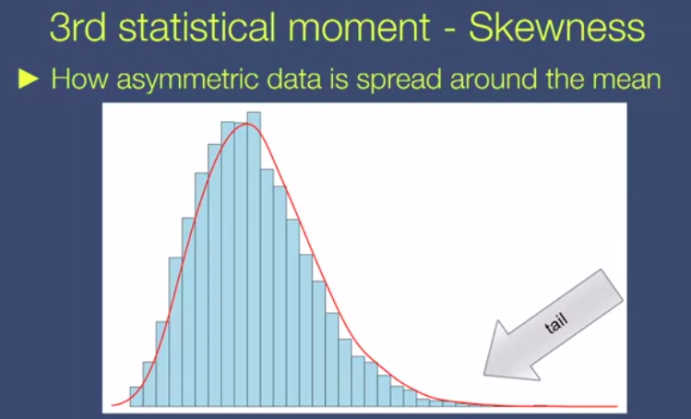

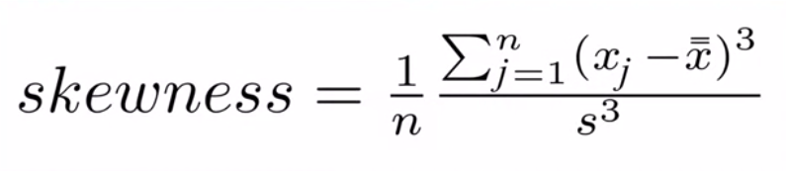

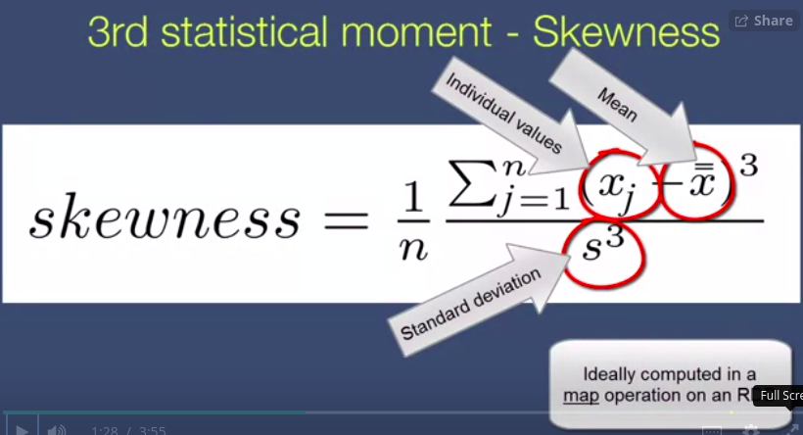

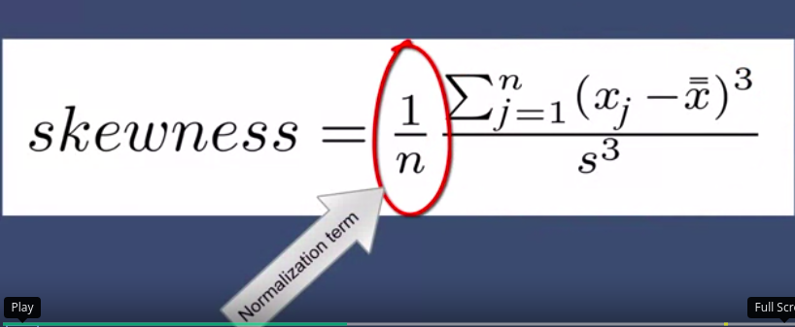

Implementing on spark:

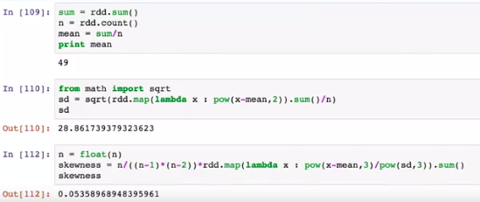

Note: **n/( (n-1)*(n-2))**  is wrong!!!! Use **1/n** instead

Skewness : in a histogram : **Right Skewed/ Left skewed**

**Kurtosis**

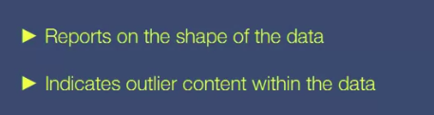

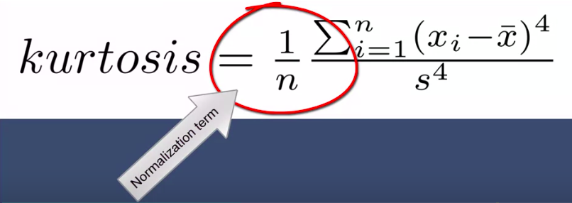

Note : Please use sum/ float(n) to find the mean in spak

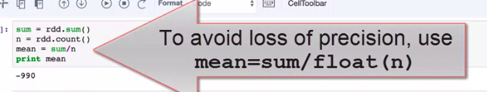

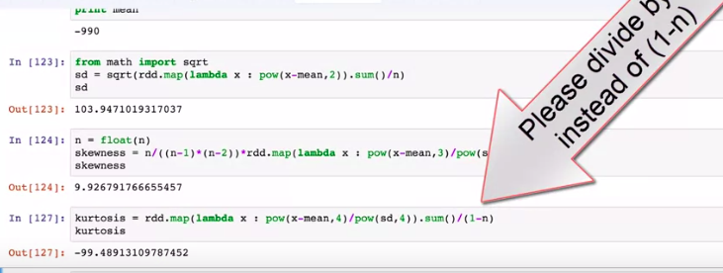

**Note: divide by n, instead of 1/n**

**Covariance and Covariance Matrices**

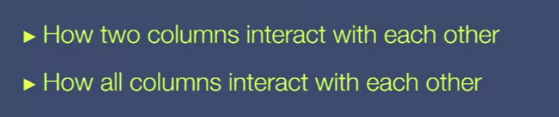

Ex: When volume increases weight increases

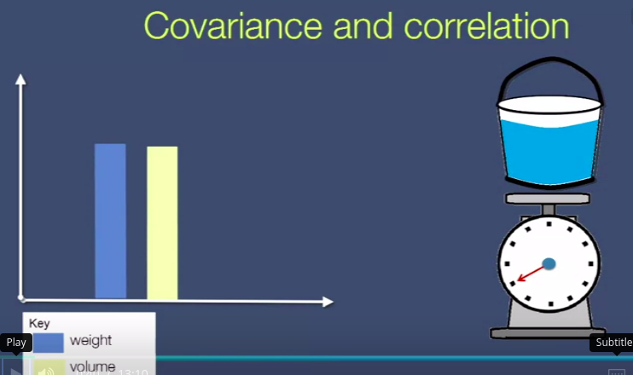

Multiple covariance:

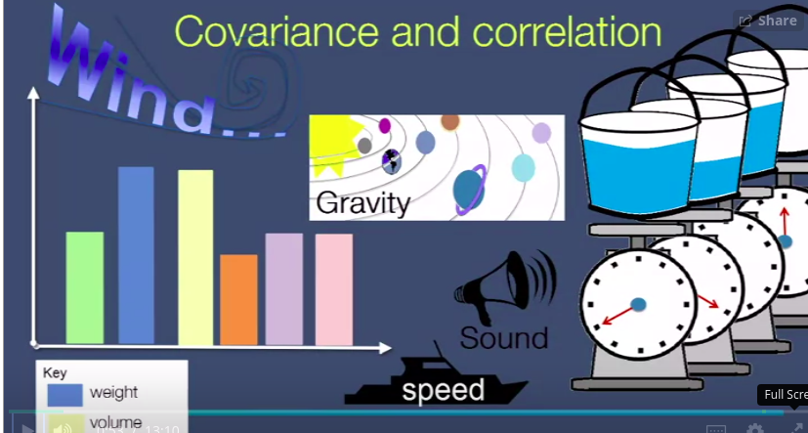

Ex: covariance is -1

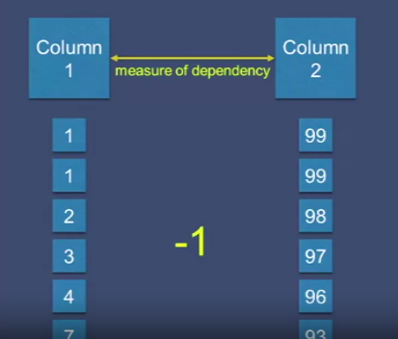

Ex: covariance is +1

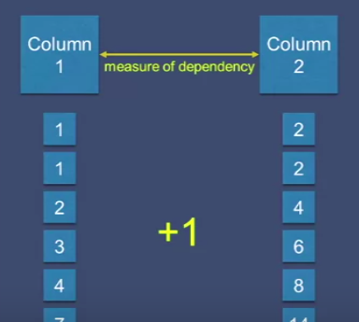

If two columns has no dependent at all, the covariance = 0

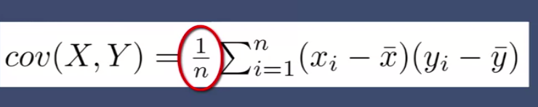

Implementation in spark:

Step 1:

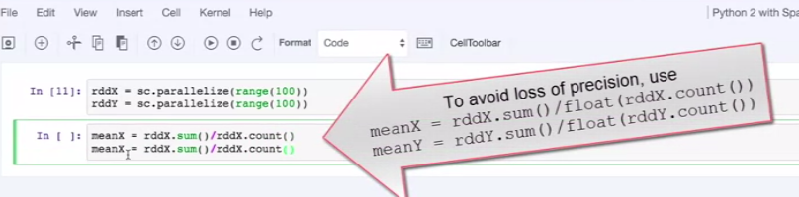

Step 2:

Note: **newRdd = rdd1.zip(rdd2)**

Zipping 2 rdds together as one RDD

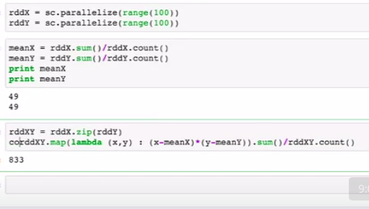

Measures of dependency in correlation:

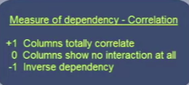

Correlation:

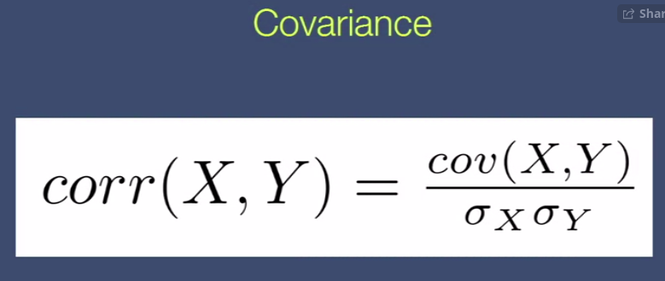

**Covariance of both columns**

**---------------------------------------**

**Sd of colX * sd of col Y**

Implementation in spark:

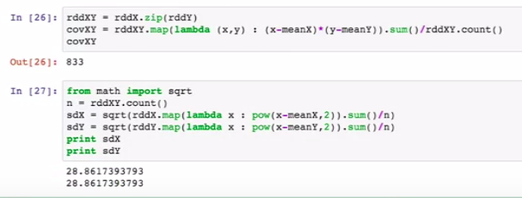

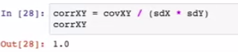

Note: **2 RDDs are totally correlating with each other ( Reason: both contain same data)**

Ex 2: Reverse the 2nd RDD



o/p : -1.0

Note: **Total inverse dependency**

Ex 3: Use 2 random lists



O/p : 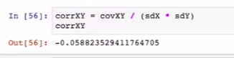

Note: value is close to 0 (no much correlation/ **if 0 - no correlation** at all)

**Correlation Matrix**



To View of all columns correlation at once..

Ex:

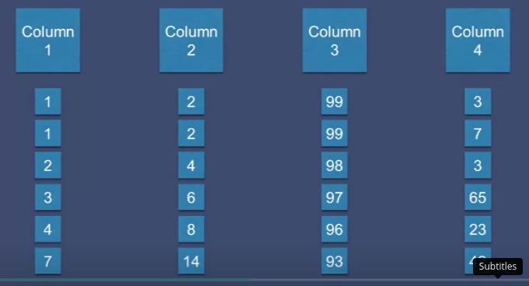

Col1 : col 2 (correlation = 1.0)

Col1 : col3 (correlation = -1.0)

Col1 : col4 (correlation = close to 0 - random values)

Ex:

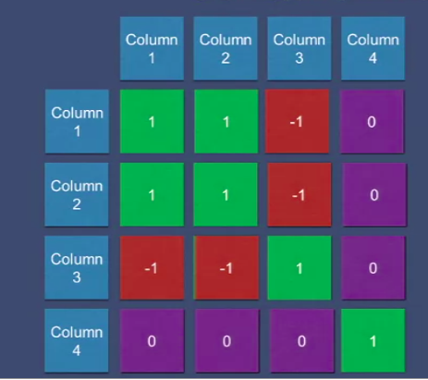

Implementation in spark:

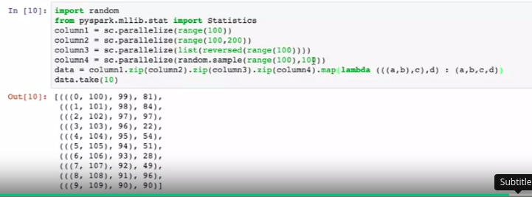

Note: **map** function is used to flatten all data to value 4 tuples

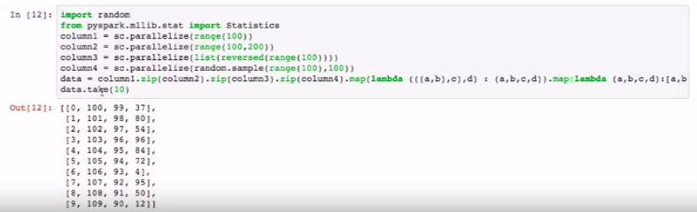

Now it looks like a relational database

Finally, get correlations:

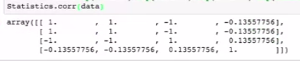

**Multidimensional vector specs:**

How data scientists call columns?

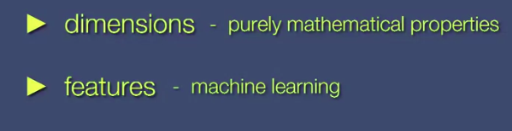

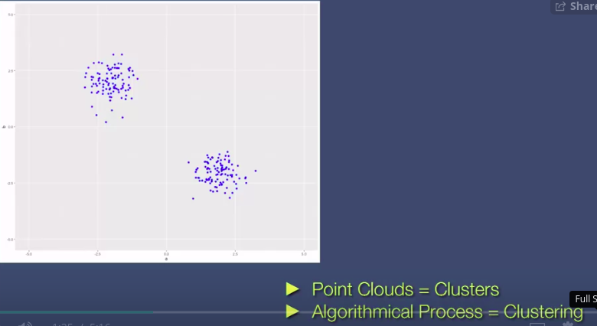

When 3 dimensions: 3-dimensional vector-space:

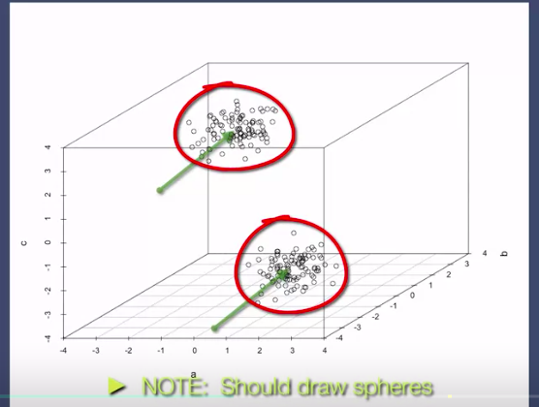

When 3+ dimensions: (hyperplane)

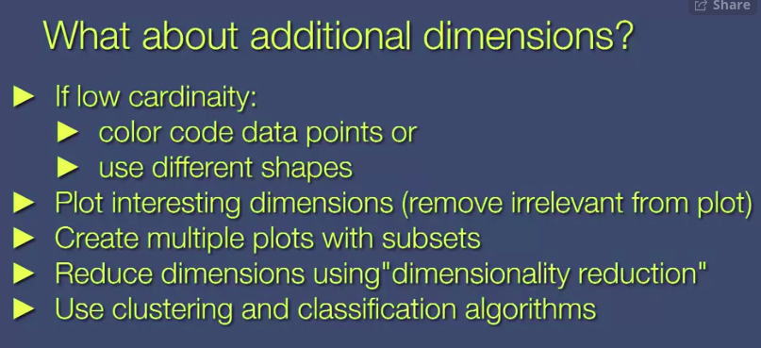

**Data Visualization**

Matplotlib:

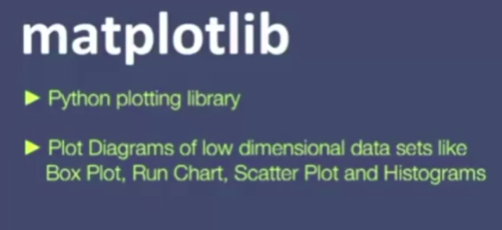

We plot only samples:

Reason: data processed in many machines ( not correctly plotted)

1. Box plot - Histogram in a vertical perspective

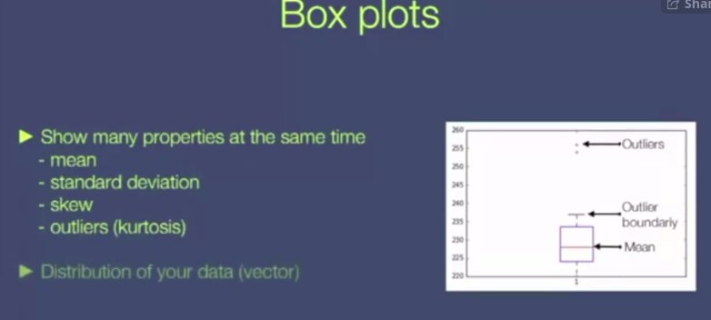

Showing all created matplotlib diagrams:

**Matplotlib inline**

1. Run charts

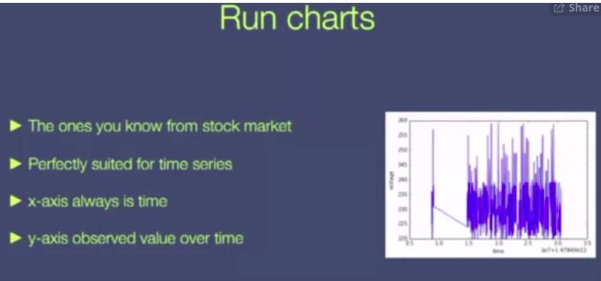

**Dimensionality reduction**

Projection process :

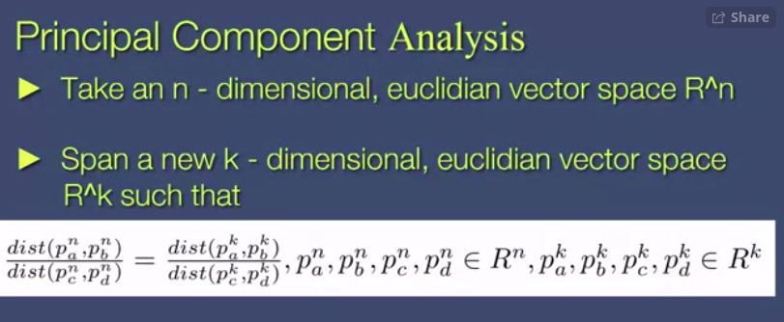

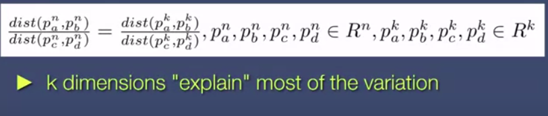

Loss:

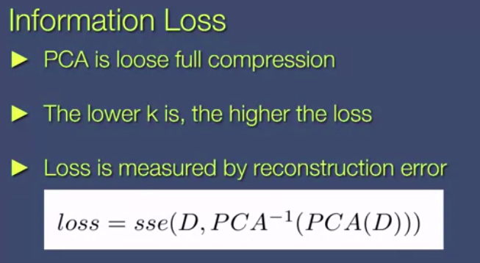

D- Original DataSet

PCA - Principal Component Analysis